44.15: a) With 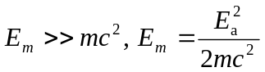Eq. (44.11).
So 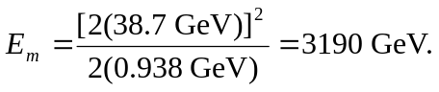
b) For colliding beams the available energy 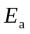 is that of both beams. So two
proton beams colliding would each need energy of 38.7 GeV to give a total of 77.4 GeV.

